**CORREAS AUTOMOTRICES**

CORREAS SIN COBERTURA CON BORDES CORTADOS

CORREAS EN V CON MULTIPLES NERVADURAS

CORREAS DE DISTRIBUCION O SINCRONIZADORAS

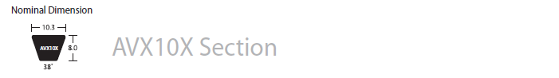

|  |  |  |  |
| --- | --- | --- | --- |
| **No. Correa** | **Peso Estimado (kg)** | **Circunferencia (mm)** | **Circunferencia (in)** |
| AVX-10X540 | 0.0440 | 545 | 21.457 |
| AVX-10X550 | 0.0450 | 555 | 21.850 |
| AVX-10X580 | 0.0470 | 585 | 23.032 |
| AVX-10X593 | 0.0480 | 598 | 23.543 |
| AVX-10X600 | 0.0490 | 605 | 23.819 |
| AVX-10X610 | 0.0500 | 615 | 24.213 |
| AVX-10X613 | 0.0500 | 618 | 24.331 |
| AVX-10X617 | 0.0500 | 622 | 24.488 |
| AVX-10X625 | 0.0510 | 630 | 24.803 |
| AVX-10X630 | 0.0510 | 635 | 25.000 |
| AVX-10X635 | 0.0520 | 640 | 25.197 |
| AVX-10X643 | 0.0530 | 648 | 25.512 |
| AVX-10X650 | 0.0530 | 655 | 25.787 |
| AVX-10X660 | 0.0540 | 665 | 26.181 |
| AVX-10X666 | 0.0540 | 671 | 26.417 |
| AVX-10X675 | 0.0550 | 680 | 26.772 |
| AVX-10X680 | 0.0560 | 685 | 26.969 |
| AVX-10X685 | 0.0560 | 690 | 27.165 |

|  |  |  |  |
| --- | --- | --- | --- |
| **No. Correa** | **Peso Estimado (kg)** | **Circunferencia (mm)** | **Circunferencia (in)** |
| AVX-10X690 | 0.0560 | 695 | 27.362 |
| AVX-10X695 | 0.0570 | 700 | 27.559 |
| AVX-10X700 | 0.0570 | 705 | 27.756 |
| AVX-10X710 | 0.0580 | 715 | 28.150 |
| AVX-10X715 | 0.0580 | 720 | 28.346 |
| AVX-10X725 | 0.0590 | 730 | 28.740 |
| AVX-10X730 | 0.0600 | 735 | 28.937 |
| AVX-10X735 | 0.0600 | 740 | 29.134 |
| AVX-10X740 | 0.0600 | 745 | 29.331 |
| AVX-10X750 | 0.0610 | 755 | 29.724 |
| AVX-10X757 | 0.0620 | 762 | 30.000 |
| AVX-10X763 | 0.0620 | 768 | 30.236 |
| AVX-10X765 | 0.0620 | 770 | 30.315 |
| AVX-10X770 | 0.0630 | 775 | 30.512 |
| AVX-10X775 | 0.0630 | 780 | 30.709 |
| AVX-10X785 | 0.0640 | 790 | 31.102 |
| AVX-10X788 | 0.0640 | 793 | 31.220 |
| AVX-10X795 | 0.0650 | 800 | 31.496 |
| AVX-10X800 | 0.0650 | 805 | 31.693 |
| AVX-10X813 | 0.0660 | 818 | 32.205 |
| AVX-10X818 | 0.0670 | 823 | 32.402 |
| AVX-10X825 | 0.0670 | 830 | 32.677 |
| AVX-10X838 | 0.0680 | 843 | 33.189 |
| AVX-10X850 | 0.0690 | 855 | 33.661 |
| AVX-10X858 | 0.0700 | 863 | 33.976 |
| AVX-10X864 | 0.0710 | 869 | 34.213 |
| AVX-10X865 | 0.0710 | 870 | 34.252 |
| AVX-10X875 | 0.0710 | 880 | 34.646 |
| AVX-10X888 | 0.0730 | 893 | 35.157 |
| AVX-10X900 | 0.0740 | 905 | 35.630 |
| AVX-10X905 | 0.0740 | 910 | 35.827 |
| AVX-10X912 | 0.0740 | 917 | 36.102 |
| AVX-10X913 | 0.0750 | 918 | 36.142 |
| AVX-10X918 | 0.0750 | 923 | 36.339 |
| AVX-10X920 | 0.0750 | 925 | 36.417 |
| AVX-10X925 | 0.0760 | 930 | 36.614 |
| AVX-10X930 | 0.0760 | 935 | 36.811 |
| AVX-10X935 | 0.0760 | 940 | 37.008 |
| AVX-10X940 | 0.0770 | 945 | 37.205 |
| AVX-10X950 | 0.0780 | 955 | 37.598 |
| AVX-10X960 | 0.0780 | 965 | 37.992 |
| AVX-10X965 | 0.0790 | 970 | 38.189 |

|  |  |  |  |
| --- | --- | --- | --- |
| **No. Correa** | **Peso Estimado (kg)** | **Circunferencia (mm)** | **Circunferencia (in)** |
| AVX-10X970 | 0.0790 | 975 | 38.386 |
| AVX-10X975 | 0.0800 | 980 | 38.583 |
| AVX-10X978 | 0.0800 | 983 | 38.701 |
| AVX-10X980 | 0.0800 | 985 | 38.780 |
| AVX-10X983 | 0.0800 | 988 | 38.898 |
| AVX-10X990 | 0.0810 | 995 | 39.173 |
| AVX-10X995 | 0.0810 | 1,000 | 39.370 |
| AVX-10X1000 | 0.0820 | 1,005 | 39.567 |
| AVX-10X1005 | 0.0820 | 1,010 | 39.764 |
| AVX-10X1007 | 0.0820 | 1,012 | 39.843 |
| AVX-10X1013 | 0.0830 | 1,018 | 40.079 |
| AVX-10X1025 | 0.0840 | 1,030 | 40.551 |
| AVX-10X1035 | 0.0850 | 1,040 | 40.945 |
| AVX-10X1037 | 0.0850 | 1,042 | 41.024 |
| AVX-10X1050 | 0.0860 | 1,055 | 41.535 |
| AVX-10X1050 | 0.0860 | 1,055 | 41.535 |
| AVX-10X1060 | 0.0870 | 1,065 | 41.929 |
| AVX-10X1065 | 0.0870 | 1,070 | 42.126 |
| AVX-10X1070 | 0.0870 | 1,075 | 42.323 |
| AVX-10X1075 | 0.0880 | 1,080 | 42.520 |
| AVX-10X1080 | 0.0880 | 1,085 | 42.717 |
| AVX-10X1085 | 0.0890 | 1,090 | 42.913 |
| AVX-10X1090 | 0.0890 | 1,095 | 43.110 |
| AVX-10X1100 | 0.0900 | 1,105 | 43.504 |
| AVX-10X1110 | 0.0910 | 1,115 | 43.898 |
| AVX-10X1113 | 0.0910 | 1,118 | 44.016 |
| AVX-10X1125 | 0.0920 | 1,130 | 44.488 |
| AVX-10X1133 | 0.0930 | 1,138 | 44.803 |
| AVX-10X1140 | 0.0930 | 1,145 | 45.079 |
| AVX-10X1150 | 0.0940 | 1,155 | 45.472 |
| AVX-10X1155 | 0.0940 | 1,160 | 45.669 |
| AVX-10X1160 | 0.0950 | 1,165 | 45.866 |
| AVX-10X1165 | 0.0950 | 1,170 | 46.063 |
| AVX-10X1170 | 0.0960 | 1,175 | 46.260 |
| AVX-10X1175 | 0.0960 | 1,180 | 46.457 |
| AVX-10X1184 | 0.0970 | 1,189 | 46.811 |
| AVX-10X1190 | 0.0970 | 1,195 | 47.047 |
| AVX-10X1200 | 0.0980 | 1,205 | 47.441 |
| AVX-10X1215 | 0.0990 | 1,220 | 48.032 |
| AVX-10X1225 | 0.1000 | 1,230 | 48.425 |
| AVX-10X1235 | 0.1010 | 1,240 | 48.819 |
| AVX-10X1238 | 0.1010 | 1,243 | 48.937 |

|  |  |  |  |
| --- | --- | --- | --- |
| **No. Correa** | **Peso Estimado (kg)** | **Circunferencia (mm)** | **Circunferencia (in)** |
| AVX-10X1240 | 0.1010 | 1,245 | 49.016 |
| AVX-10X1250 | 0.1020 | 1,255 | 49.409 |
| AVX-10X1270 | 0.1040 | 1,275 | 50.197 |
| AVX-10X1275 | 0.1040 | 1,280 | 50.394 |
| AVX-10X1290 | 0.1050 | 1,295 | 50.984 |
| AVX-10X1300 | 0.1060 | 1,305 | 51.378 |
| AVX-10X1310 | 0.1070 | 1,315 | 51.772 |
| AVX-10X1325 | 0.1080 | 1,330 | 52.362 |
| AVX-10X1340 | 0.1090 | 1,345 | 52.953 |
| AVX-10X1350 | 0.1100 | 1,355 | 53.346 |
| AVX-10X1375 | 0.1120 | 1,380 | 54.331 |
| AVX-10X1400 | 0.1140 | 1,405 | 55.315 |
| AVX-10X1425 | 0.1160 | 1,430 | 56.299 |
| AVX-10X1450 | 0.1180 | 1,455 | 57.283 |
| AVX-10X1475 | 0.1200 | 1,480 | 58.268 |
| AVX-10X1500 | 0.1230 | 1,505 | 59.252 |
| AVX-10X1525 | 0.1250 | 1,530 | 60.236 |
| AVX-10X1550 | 0.1270 | 1,555 | 61.221 |
| AVX-10X1575 | 0.1290 | 1,580 | 62.205 |
| AVX-10X1600 | 0.1310 | 1,605 | 63.189 |
| AVX-10X1625 | 0.1330 | 1,630 | 64.173 |
| AVX-10X1650 | 0.1350 | 1,655 | 65.158 |
| AVX-10X1775 | 0.1450 | 1,780 | 70.079 |
| AVX-10X1825 | 0.1490 | 1,830 | 72.047 |

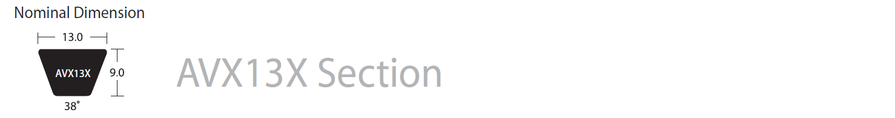

|  |  |  |  |
| --- | --- | --- | --- |
| **No. Correa** | **Peso Estimado (kg)** | **Circunferencia (mm)** | **Circunferencia (in)** |
| AVX-13X600 | 0.065 | 603 | 23.740 |
| AVX-13X610 | 0.066 | 613 | 24.134 |
| AVX-13X620 | 0.067 | 623 | 24.528 |
| AVX-13X625 | 0.068 | 628 | 24.724 |
| AVX-13X640 | 0.069 | 643 | 25.315 |
| AVX-13X650 | 0.07 | 653 | 25.709 |
| AVX-13X655 | 0.071 | 658 | 25.906 |
| AVX-13X670 | 0.073 | 673 | 26.496 |
| AVX-13X675 | 0.074 | 678 | 26.693 |
| AVX-13X680 | 0.074 | 683 | 26.890 |
| AVX-13X685 | 0.075 | 688 | 27.087 |
| AVX-13X690 | 0.075 | 693 | 27.283 |
| AVX-13X700 | 0.076 | 703 | 27.677 |
| AVX-13X710 | 0.077 | 713 | 28.071 |
| AVX-13X715 | 0.077 | 718 | 28.268 |
| AVX-13X725 | 0.078 | 728 | 28.661 |
| AVX-13X750 | 0.081 | 753 | 29.646 |
| AVX-13X765 | 0.083 | 768 | 30.236 |
| AVX-13X775 | 0.084 | 778 | 30.630 |
| AVX-13X780 | 0.085 | 783 | 30.827 |
| AVX-13X784 | 0.086 | 787 | 30.984 |
| AVX-13X785 | 0.086 | 788 | 31.024 |
| AVX-13X795 | 0.087 | 798 | 31.417 |
| AVX-13X800 | 0.087 | 803 | 31.614 |
| AVX-13X805 | 0.088 | 808 | 31.811 |
| AVX-13X810 | 0.088 | 813 | 32.008 |
| AVX-13X818 | 0.09 | 821 | 32.323 |
| AVX-13X825 | 0.09 | 828 | 32.598 |
| AVX-13X830 | 0.09 | 833 | 32.795 |
| AVX-13X835 | 0.09 | 838 | 32.992 |
| AVX-13X840 | 0.091 | 843 | 33.189 |
| AVX-13X850 | 0.092 | 853 | 33.583 |
| AVX-13X855 | 0.093 | 858 | 33.780 |
| AVX-13X860 | 0.093 | 863 | 33.976 |
| AVX-13X865 | 0.095 | 868 | 34.173 |
| AVX-13X868 | 0.095 | 871 | 34.291 |
| AVX-13X875 | 0.096 | 878 | 34.567 |
| AVX-13X885 | 0.096 | 888 | 34.961 |

|  |  |  |  |
| --- | --- | --- | --- |
| **No. Correa** | **Peso Estimado (kg)** | **Circunferencia (mm)** | **Circunferencia (in)** |
| AVX-13X890 | 0.097 | 893 | 35.157 |
| AVX-13X900 | 0.098 | 903 | 35.551 |
| AVX-13X910 | 0.099 | 913 | 35.945 |
| AVX-13X915 | 0.1 | 918 | 36.142 |
| AVX-13X918 | 0.1 | 921 | 36.260 |
| AVX-13X920 | 0.101 | 923 | 36.339 |
| AVX-13X925 | 0.102 | 928 | 36.535 |
| AVX-13X930 | 0.102 | 933 | 36.732 |
| AVX-13X938 | 0.102 | 941 | 37.047 |
| AVX-13X947 | 0.103 | 950 | 37.402 |
| AVX-13X950 | 0.103 | 953 | 37.520 |
| AVX-13X955 | 0.103 | 958 | 37.717 |
| AVX-13X960 | 0.105 | 963 | 37.913 |
| AVX-13X968 | 0.105 | 971 | 38.228 |
| AVX-13X975 | 0.106 | 978 | 38.504 |
| AVX-13X985 | 0.106 | 988 | 38.898 |
| AVX-13X990 | 0.107 | 993 | 39.095 |
| AVX-13X992 | 0.107 | 995 | 39.173 |
| AVX-13X1000 | 0.108 | 1003 | 39.488 |
| AVX-13X1015 | 0.109 | 1018 | 40.079 |
| AVX-13X1025 | 0.111 | 1028 | 40.472 |
| AVX-13X1030 | 0.111 | 1033 | 40.669 |
| AVX-13X1040 | 0.113 | 1043 | 41.063 |
| AVX-13X1050 | 0.113 | 1053 | 41.457 |
| AVX-13X1055 | 0.114 | 1058 | 41.654 |
| AVX-13X1060 | 0.114 | 1063 | 41.850 |
| AVX-13X1075 | 0.116 | 1078 | 42.441 |
| AVX-13X1085 | 0.118 | 1088 | 42.835 |
| AVX-13X1100 | 0.119 | 1103 | 43.425 |
| AVX-13X1110 | 0.12 | 1113 | 43.819 |
| AVX-13X1118 | 0.121 | 1121 | 44.134 |
| AVX-13X1120 | 0.121 | 1123 | 44.213 |
| AVX-13X1125 | 0.121 | 1128 | 44.409 |
| AVX-13X1138 | 0.123 | 1141 | 44.921 |
| AVX-13X1145 | 0.124 | 1148 | 45.197 |
| AVX-13X1150 | 0.124 | 1153 | 45.394 |
| AVX-13X1155 | 0.125 | 1158 | 45.591 |
| AVX-13X1160 | 0.126 | 1163 | 45.787 |
| AVX-13X1165 | 0.126 | 1168 | 45.984 |
| AVX-13X1175 | 0.127 | 1178 | 46.378 |
| AVX-13X1184 | 0.128 | 1187 | 46.732 |
| AVX-13X1188 | 0.128 | 1191 | 46.890 |

|  |  |  |  |
| --- | --- | --- | --- |
| **No. Correa** | **Peso Estimado (kg)** | **Circunferencia (mm)** | **Circunferencia (in)** |
| AVX-13X1200 | 0.129 | 1203 | 47.362 |
| AVX-13X1225 | 0.132 | 1228 | 48.346 |
| AVX-13X1235 | 0.133 | 1238 | 48.740 |
| AVX-13X1250 | 0.135 | 1253 | 49.331 |
| AVX-13X1260 | 0.136 | 1263 | 49.724 |
| AVX-13X1275 | 0.138 | 1278 | 50.315 |
| AVX-13X1285 | 0.139 | 1288 | 50.709 |
| AVX-13X1290 | 0.139 | 1293 | 50.906 |
| AVX-13X1300 | 0.14 | 1303 | 51.299 |
| AVX-13X1325 | 0.143 | 1328 | 52.283 |
| AVX-13X1338 | 0.144 | 1341 | 52.795 |
| AVX-13X1350 | 0.146 | 1353 | 53.268 |
| AVX-13X1375 | 0.148 | 1378 | 54.252 |
| AVX-13X1385 | 0.149 | 1388 | 54.646 |
| AVX-13X1400 | 0.151 | 1403 | 55.236 |
| AVX-13X1410 | 0.152 | 1413 | 55.630 |
| AVX-13X1425 | 0.154 | 1428 | 56.221 |
| AVX-13X1443 | 0.156 | 1446 | 56.929 |
| AVX-13X1450 | 0.156 | 1453 | 57.205 |
| AVX-13X1460 | 0.157 | 1463 | 57.598 |
| AVX-13X1475 | 0.159 | 1478 | 58.189 |
| AVX-13X1485 | 0.16 | 1488 | 58.583 |
| AVX-13X1500 | 0.162 | 1503 | 59.173 |
| AVX-13X1518 | 0.164 | 1521 | 59.882 |
| AVX-13X1525 | 0.164 | 1528 | 60.158 |
| AVX-13X1535 | 0.166 | 1538 | 60.551 |
| AVX-13X1550 | 0.167 | 1553 | 61.142 |
| AVX-13X1575 | 0.17 | 1578 | 62.126 |
| AVX-13X1600 | 0.173 | 1603 | 63.110 |
| AVX-13X1625 | 0.175 | 1628 | 64.095 |
| AVX-13X1650 | 0.178 | 1653 | 65.079 |
| AVX-13X1675 | 0.181 | 1678 | 66.063 |
| AVX-13X1693 | 0.183 | 1696 | 66.772 |
| AVX-13X1700 | 0.183 | 1703 | 67.047 |
| AVX-13X1718 | 0.185 | 1721 | 67.756 |
| AVX-13X1725 | 0.186 | 1728 | 68.032 |
| AVX-13X1750 | 0.189 | 1753 | 69.016 |
| AVX-13X1775 | 0.191 | 1778 | 70.000 |
| AVX-13X1800 | 0.194 | 1803 | 70.984 |
| AVX-13X1825 | 0.197 | 1828 | 71.969 |
| AVX-13X1850 | 0.2 | 1853 | 72.953 |
| AVX-13X1863 | 0.201 | 1866 | 73.465 |

|  |  |  |  |
| --- | --- | --- | --- |
| **No. Correa** | **Peso Estimado (kg)** | **Circunferencia (mm)** | **Circunferencia (in)** |
| AVX-13X1875 | 0.202 | 1878 | 73.937 |
| AVX-13X1900 | 0.205 | 1903 | 74.921 |
| AVX-13X1925 | 0.208 | 1928 | 75.906 |
| AVX-13X1950 | 0.21 | 1953 | 76.890 |
| AVX-13X1975 | 0.213 | 1978 | 77.874 |
| AVX-13X2000 | 0.216 | 2003 | 78.858 |
| AVX-13X2075 | 0.224 | 2078 | 81.811 |
| AVX-13X2100 | 0.227 | 2103 | 82.795 |
| AVX-13X2125 | 0.229 | 2128 | 83.780 |
| AVX-13X2200 | 0.237 | 2203 | 86.732 |
| AVX-13X2400 | 0.259 | 2403 | 94.606 |
| AVX-13X2450 | 0.264 | 2453 | 96.575 |

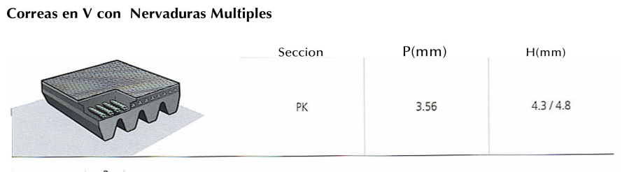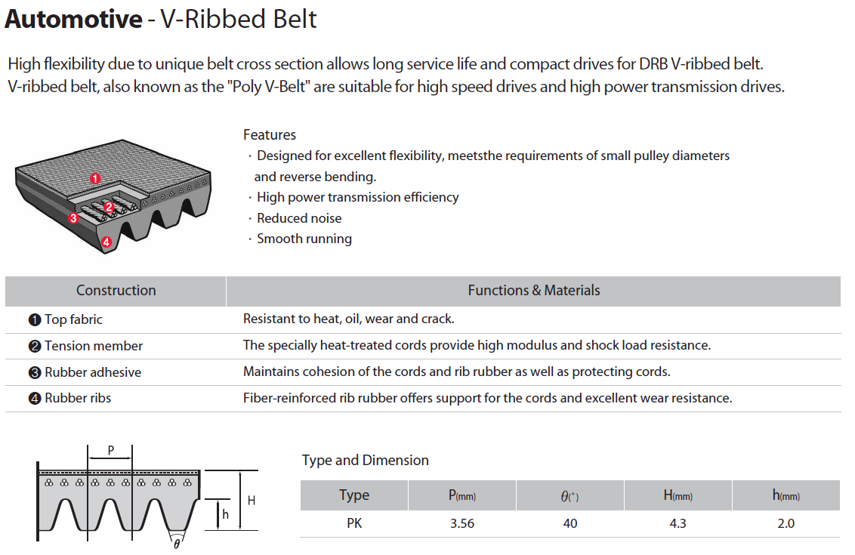

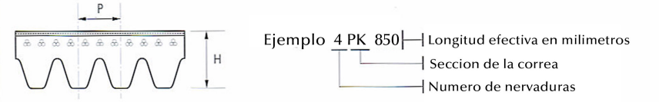

**3PK**

|  |  |  |  |
| --- | --- | --- | --- |
| **No. Correa** | **Peso Estimado (kg)** | **Circunferencia (mm)** | **Circunferencia (in)** |
| 3PK560 | 0.029 | 560 | 22.047 |
| 3PK590 | 0.031 | 590 | 23.228 |
| 3PK600 | 0.031 | 600 | 23.622 |
| 3PK630 | 0.033 | 630 | 24.803 |
| 3PK665 | 0.035 | 665 | 26.181 |
| 3PK670 | 0.035 | 670 | 26.378 |
| 3PK675 | 0.035 | 675 | 26.575 |
| 3PK690 | 0.036 | 690 | 27.165 |
| 3PK715 | 0.037 | 715 | 28.150 |
| 3PK735 | 0.038 | 735 | 28.937 |
| 3PK750 | 0.039 | 750 | 29.528 |
| 3PK760 | 0.039 | 760 | 29.921 |
| 3PK765 | 0.040 | 765 | 30.118 |
| 3PK780 | 0.040 | 780 | 30.709 |
| 3PK785 | 0.041 | 785 | 30.906 |

|  |  |  |  |
| --- | --- | --- | --- |
| **No. Correa** | **Peso Estimado (kg)** | **Circunferencia (mm)** | **Circunferencia (in)** |
| 3PK790 | 0.041 | 790 | 31.102 |
| 3PK800 | 0.041 | 800 | 31.496 |
| 3PK815 | 0.042 | 815 | 32.087 |
| 3PK820 | 0.042 | 820 | 32.283 |
| 3PK825 | 0.043 | 825 | 32.480 |
| 3PK830 | 0.043 | 830 | 32.677 |
| 3PK850 | 0.044 | 850 | 33.465 |
| 3PK875 | 0.045 | 875 | 34.449 |
| 3PK880 | 0.046 | 880 | 34.646 |
| 3PK890 | 0.046 | 890 | 35.039 |
| 3PK905 | 0.047 | 905 | 35.630 |
| 3PK910 | 0.047 | 910 | 35.827 |
| 3PK915 | 0.047 | 915 | 36.024 |
| 3PK925 | 0.048 | 925 | 36.417 |
| 3PK935 | 0.048 | 935 | 36.811 |
| 3PK960 | 0.050 | 960 | 37.795 |
| 3PK975 | 0.050 | 975 | 38.386 |
| 3PK995 | 0.052 | 995 | 39.173 |
| 3PK1000 | 0.052 | 1000 | 39.370 |
| 3PK1015 | 0.053 | 1015 | 39.961 |
| 3PK1020 | 0.053 | 1020 | 40.158 |
| 3PK1025 | 0.053 | 1025 | 40.354 |
| 3PK1050 | 0.054 | 1050 | 41.339 |
| 3PK1080 | 0.056 | 1080 | 42.520 |
| 3PK1150 | 0.060 | 1150 | 45.276 |
| 3PK1220 | 0.063 | 1220 | 48.032 |
| 3PK1285 | 0.067 | 1285 | 50.591 |

**4PK**

|  |  |  |  |
| --- | --- | --- | --- |
| **No. Correa** | **Peso Estimado (kg)** | **Circunferencia (mm)** | **Circunferencia (in)** |
| 4PK545 | 0.038 | 545 | 21.457 |
| 4PK560 | 0.039 | 560 | 22.047 |
| 4PK590 | 0.041 | 590 | 23.228 |
| 4PK605 | 0.042 | 605 | 23.819 |
| 4PK613 | 0.043 | 613 | 24.134 |
| 4PK635 | 0.044 | 635 | 25.000 |
| 4PK640 | 0.044 | 640 | 25.197 |
| 4PK650 | 0.045 | 650 | 25.591 |
| 4PK665 | 0.046 | 665 | 26.181 |
| 4PK675 | 0.047 | 675 | 26.575 |
| 4PK685 | 0.047 | 685 | 26.969 |
| 4PK700 | 0.048 | 700 | 27.559 |
| 4PK715 | 0.049 | 715 | 28.150 |
| 4PK718 | 0.050 | 718 | 28.268 |
| 4PK725 | 0.050 | 725 | 28.543 |
| 4PK755 | 0.052 | 755 | 29.724 |
| 4PK760 | 0.052 | 760 | 29.921 |
| 4PK770 | 0.053 | 770 | 30.315 |
| 4PK775 | 0.054 | 775 | 30.512 |
| 4PK778 | 0.054 | 778 | 30.630 |
| 4PK785 | 0.054 | 785 | 30.906 |
| 4PK790 | 0.055 | 790 | 31.102 |
| 4PK800 | 0.055 | 800 | 31.496 |
| 4PK809 | 0.056 | 809 | 31.850 |
| 4PK810 | 0.056 | 810 | 31.890 |
| 4PK812 | 0.056 | 812 | 31.969 |
| 4PK815 | 0.056 | 815 | 32.087 |
| 4PK825 | 0.057 | 825 | 32.480 |
| 4PK829 | 0.057 | 829 | 32.638 |
| 4PK830 | 0.057 | 830 | 32.677 |
| 4PK845 | 0.058 | 845 | 33.268 |
| 4PK848 | 0.059 | 848 | 33.386 |
| 4PK850 | 0.059 | 850 | 33.465 |
| 4PK855 | 0.059 | 855 | 33.661 |
| 4PK865 | 0.060 | 865 | 34.055 |
| 4PK870 | 0.060 | 870 | 34.252 |
| 4PK875 | 0.060 | 875 | 34.449 |
| 4PK885 | 0.061 | 885 | 34.843 |
| 4PK890 | 0.061 | 890 | 35.039 |
| 4PK897 | 0.062 | 897 | 35.315 |
| 4PK900 | 0.062 | 900 | 35.433 |
| 4PK905 | 0.062 | 905 | 35.630 |

|  |  |  |  |
| --- | --- | --- | --- |
| **No. Correa** | **Peso Estimado (kg)** | **Circunferencia (mm)** | **Circunferencia (in)** |
| 4PK910 | 0.063 | 910 | 35.827 |
| 4PK915 | 0.063 | 915 | 36.024 |
| 4PK920 | 0.064 | 920 | 36.220 |
| 4PK925 | 0.064 | 925 | 36.417 |
| 4PK930 | 0.065 | 930 | 36.614 |
| 4PK935 | 0.065 | 935 | 36.811 |
| 4PK940 | 0.065 | 940 | 37.008 |
| 4PK945 | 0.065 | 945 | 37.205 |
| 4PK950 | 0.066 | 950 | 37.402 |
| 4PK960 | 0.067 | 960 | 37.795 |
| 4PK965 | 0.067 | 965 | 37.992 |
| 4PK967 | 0.067 | 967 | 38.071 |
| 4PK970 | 0.067 | 970 | 38.189 |
| 4PK975 | 0.067 | 975 | 38.386 |
| 4PK980 | 0.068 | 980 | 38.583 |
| 4PK985 | 0.068 | 985 | 38.780 |
| 4PK990 | 0.068 | 990 | 38.976 |
| 4PK995 | 0.069 | 995 | 39.173 |
| 4PK1000 | 0.069 | 1000 | 39.370 |
| 4PK1015 | 0.070 | 1015 | 39.961 |
| 4PK1020 | 0.070 | 1020 | 40.158 |
| 4PK1045 | 0.072 | 1045 | 41.142 |
| 4PK1060 | 0.073 | 1060 | 41.732 |
| 4PK1075 | 0.074 | 1075 | 42.323 |
| 4PK1080 | 0.075 | 1080 | 42.520 |
| 4PK1082 | 0.075 | 1082 | 42.598 |
| 4PK1090 | 0.075 | 1090 | 42.913 |
| 4PK1100 | 0.076 | 1100 | 43.307 |
| 4PK1105 | 0.076 | 1105 | 43.504 |
| 4PK1115 | 0.077 | 1115 | 43.898 |
| 4PK1125 | 0.078 | 1125 | 44.291 |
| 4PK1165 | 0.080 | 1165 | 45.866 |
| 4PK1190 | 0.082 | 1190 | 46.850 |
| 4PK1230 | 0.085 | 1230 | 48.425 |
| 4PK1245 | 0.086 | 1245 | 49.016 |
| 4PK1325 | 0.091 | 1325 | 52.165 |
| 4PK1360 | 0.094 | 1360 | 53.543 |
| 4PK1450 | 0.100 | 1450 | 57.087 |
| 4PK1460 | 0.101 | 1460 | 57.480 |
| 4PK1485 | 0.103 | 1485 | 58.465 |
| 4PK1520 | 0.105 | 1520 | 59.843 |

**5PK**

|  |  |  |  |
| --- | --- | --- | --- |
| **No. Correa** | **Peso Estimado (kg)** | **Circunferencia (mm)** | **Circunferencia (in)** |
| 5PK575 | 0.050 | 575 | 22.638 |
| 5PK675 | 0.058 | 675 | 26.575 |
| 5PK710 | 0.061 | 710 | 27.953 |
| 5PK715 | 0.062 | 715 | 28.150 |
| 5PK725 | 0.063 | 725 | 28.543 |
| 5PK775 | 0.067 | 775 | 30.512 |
| 5PK785 | 0.068 | 785 | 30.906 |
| 5PK790 | 0.068 | 790 | 31.102 |
| 5PK800 | 0.069 | 800 | 31.496 |
| 5PK820 | 0.071 | 820 | 32.283 |
| 5PK825 | 0.071 | 825 | 32.480 |
| 5PK830 | 0.072 | 830 | 32.677 |
| 5PK850 | 0.073 | 850 | 33.465 |
| 5PK865 | 0.075 | 865 | 34.055 |
| 5PK870 | 0.076 | 870 | 34.252 |
| 5PK875 | 0.076 | 875 | 34.449 |
| 5PK890 | 0.077 | 890 | 35.039 |
| 5PK900 | 0.078 | 900 | 35.433 |
| 5PK905 | 0.078 | 905 | 35.630 |
| 5PK906 | 0.078 | 906 | 35.669 |
| 5PK915 | 0.079 | 915 | 36.024 |
| 5PK920 | 0.079 | 920 | 36.220 |
| 5PK925 | 0.080 | 925 | 36.417 |
| 5PK930 | 0.080 | 930 | 36.614 |
| 5PK940 | 0.081 | 940 | 37.008 |
| 5PK950 | 0.082 | 950 | 37.402 |
| 5PK955 | 0.082 | 955 | 37.598 |
| 5PK970 | 0.084 | 970 | 38.189 |
| 5PK975 | 0.084 | 975 | 38.386 |
| 5PK980 | 0.085 | 980 | 38.583 |
| 5PK985 | 0.085 | 985 | 38.780 |
| 5PK990 | 0.085 | 990 | 38.976 |
| 5PK1000 | 0.086 | 1000 | 39.370 |
| 5PK1005 | 0.087 | 1005 | 39.567 |
| 5PK1008 | 0.087 | 1008 | 39.685 |
| 5PK1010 | 0.087 | 1010 | 39.764 |
| 5PK1015 | 0.088 | 1015 | 39.961 |
| 5PK1025 | 0.088 | 1025 | 40.354 |
| 5PK1030 | 0.089 | 1030 | 40.551 |
| 5PK1040 | 0.090 | 1040 | 40.945 |
| 5PK1045 | 0.090 | 1045 | 41.142 |
| 5PK1050 | 0.090 | 1050 | 41.339 |

|  |  |  |  |
| --- | --- | --- | --- |
| **No. Correa** | **Peso Estimado (kg)** | **Circunferencia (mm)** | **Circunferencia (in)** |
| 5PK1060 | 0.091 | 1060 | 41.732 |
| 5PK1070 | 0.092 | 1070 | 42.126 |
| 5PK1075 | 0.092 | 1075 | 42.323 |
| 5PK1090 | 0.094 | 1090 | 42.913 |
| 5PK1100 | 0.095 | 1100 | 43.307 |
| 5PK1105 | 0.095 | 1105 | 43.504 |
| 5PK1110 | 0.096 | 1110 | 43.701 |
| 5PK1120 | 0.097 | 1120 | 44.095 |
| 5PK1125 | 0.097 | 1125 | 44.291 |
| 5PK1135 | 0.098 | 1135 | 44.685 |
| 5PK1140 | 0.098 | 1140 | 44.882 |
| 5PK1155 | 0.100 | 1155 | 45.472 |
| 5PK1165 | 0.101 | 1165 | 45.866 |
| 5PK1180 | 0.102 | 1180 | 46.457 |
| 5PK1190 | 0.103 | 1190 | 46.850 |
| 5PK1200 | 0.104 | 1200 | 47.244 |
| 5PK1210 | 0.104 | 1210 | 47.638 |
| 5PK1225 | 0.106 | 1225 | 48.228 |
| 5PK1230 | 0.106 | 1230 | 48.425 |
| 5PK1240 | 0.107 | 1240 | 48.819 |
| 5PK1250 | 0.108 | 1250 | 49.213 |
| 5PK1255 | 0.108 | 1255 | 49.409 |
| 5PK1260 | 0.109 | 1260 | 49.606 |
| 5PK1270 | 0.110 | 1270 | 50.000 |
| 5PK1275 | 0.110 | 1275 | 50.197 |
| 5PK1285 | 0.111 | 1285 | 50.591 |
| 5PK1290 | 0.111 | 1290 | 50.787 |
| 5PK1295 | 0.112 | 1295 | 50.984 |
| 5PK1300 | 0.112 | 1300 | 51.181 |
| 5PK1325 | 0.114 | 1325 | 52.165 |
| 5PK1330 | 0.115 | 1330 | 52.362 |
| 5PK1345 | 0.116 | 1345 | 52.953 |
| 5PK1350 | 0.117 | 1350 | 53.150 |
| 5PK1360 | 0.117 | 1360 | 53.543 |
| 5PK1385 | 0.120 | 1385 | 54.528 |
| 5PK1390 | 0.120 | 1390 | 54.724 |
| 5PK1393 | 0.120 | 1393 | 54.843 |
| 5PK1450 | 0.125 | 1450 | 57.087 |
| 5PK1465 | 0.126 | 1465 | 57.677 |
| 5PK1500 | 0.129 | 1500 | 59.055 |
| 5PK1515 | 0.131 | 1515 | 59.646 |
| 5PK1530 | 0.132 | 1530 | 60.236 |

|  |  |  |  |
| --- | --- | --- | --- |
| **No. Correa** | **Peso Estimado (kg)** | **Circunferencia (mm)** | **Circunferencia (in)** |
| 5PK1585 | 0.137 | 1585 | 62.402 |
| 5PK1592 | 0.138 | 1592 | 62.677 |
| 5PK1610 | 0.139 | 1610 | 63.386 |
| 5PK1635 | 0.141 | 1635 | 64.370 |
| 5PK1680 | 0.145 | 1680 | 66.142 |
| 5PK1720 | 0.148 | 1720 | 67.717 |
| 5PK1750 | 0.151 | 1750 | 68.898 |
| 5PK1815 | 0.157 | 1815 | 71.457 |
| 5PK1850 | 0.160 | 1850 | 72.835 |
| 5PK1885 | 0.163 | 1885 | 74.213 |
| 5PK2020 | 0.174 | 2020 | 79.528 |
| 5PK2030 | 0.175 | 2030 | 79.921 |
| 5PK2060 | 0.178 | 2060 | 81.102 |

**6PK**

|  |  |  |  |
| --- | --- | --- | --- |
| **No. Correa** | **Peso Estimado (kg)** | **Circunferencia (mm)** | **Circunferencia (in)** |
| 6PK675 | 0.070 | 675 | 26.575 |
| 6PK720 | 0.075 | 720 | 28.346 |
| 6PK725 | 0.075 | 725 | 28.543 |
| 6PK745 | 0.077 | 745 | 29.331 |
| 6PK780 | 0.081 | 780 | 30.709 |
| 6PK800 | 0.083 | 800 | 31.496 |
| 6PK820 | 0.085 | 820 | 32.283 |
| 6PK850 | 0.088 | 850 | 33.465 |
| 6PK875 | 0.091 | 875 | 34.449 |
| 6PK880 | 0.091 | 880 | 34.646 |
| 6PK890 | 0.092 | 890 | 35.039 |
| 6PK900 | 0.093 | 900 | 35.433 |
| 6PK915 | 0.095 | 915 | 36.024 |
| 6PK935 | 0.097 | 935 | 36.811 |
| 6PK950 | 0.098 | 950 | 37.402 |
| 6PK995 | 0.103 | 995 | 39.173 |
| 6PK1000 | 0.104 | 1000 | 39.370 |
| 6PK1010 | 0.105 | 1010 | 39.764 |
| 6PK1015 | 0.105 | 1015 | 39.961 |
| 6PK1020 | 0.106 | 1020 | 40.158 |
| 6PK1025 | 0.106 | 1025 | 40.354 |
| 6PK1030 | 0.107 | 1030 | 40.551 |
| 6PK1045 | 0.108 | 1045 | 41.142 |
| 6PK1050 | 0.109 | 1050 | 41.339 |
| 6PK1060 | 0.110 | 1060 | 41.732 |
| 6PK1065 | 0.110 | 1065 | 41.929 |
| 6PK1070 | 0.111 | 1070 | 42.126 |
| 6PK1075 | 0.111 | 1075 | 42.323 |
| 6PK1080 | 0.112 | 1080 | 42.520 |
| 6PK1090 | 0.113 | 1090 | 42.913 |
| 6PK1095 | 0.011 | 1095 | 43.110 |
| 6PK1100 | 0.114 | 1100 | 43.307 |
| 6PK1105 | 0.114 | 1105 | 43.504 |
| 6PK1110 | 0.115 | 1110 | 43.701 |
| 6PK1120 | 0.116 | 1120 | 44.095 |
| 6PK1125 | 0.117 | 1125 | 44.291 |
| 6PK1130 | 0.117 | 1130 | 44.488 |
| 6PK1145 | 0.119 | 1145 | 45.079 |
| 6PK1150 | 0.120 | 1150 | 45.276 |
| 6PK1165 | 0.121 | 1165 | 45.866 |
| 6PK1180 | 0.122 | 1180 | 46.457 |
| 6PK1185 | 0.123 | 1185 | 46.654 |

|  |  |  |  |
| --- | --- | --- | --- |
| **No. Correa** | **Peso Estimado (kg)** | **Circunferencia (mm)** | **Circunferencia (in)** |
| 6PK1190 | 0.123 | 1190 | 46.850 |
| 6PK1195 | 0.124 | 1195 | 47.047 |
| 6PK1200 | 0.124 | 1200 | 47.244 |
| 6PK1225 | 0.127 | 1225 | 48.228 |
| 6PK1230 | 0.127 | 1230 | 48.425 |
| 6PK1240 | 0.128 | 1240 | 48.819 |
| 6PK1250 | 0.129 | 1250 | 49.213 |
| 6PK1260 | 0.130 | 1260 | 49.606 |
| 6PK1275 | 0.132 | 1275 | 50.197 |
| 6PK1285 | 0.133 | 1285 | 50.591 |
| 6PK1300 | 0.135 | 1300 | 51.181 |
| 6PK1325 | 0.137 | 1325 | 52.165 |
| 6PK1345 | 0.139 | 1345 | 52.953 |
| 6PK1360 | 0.141 | 1360 | 53.543 |
| 6PK1370 | 0.142 | 1370 | 53.937 |
| 6PK1390 | 0.144 | 1390 | 54.724 |
| 6PK1400 | 0.145 | 1400 | 55.118 |
| 6PK1420 | 0.147 | 1420 | 55.906 |
| 6PK1440 | 0.149 | 1440 | 56.693 |
| 6PK1450 | 0.150 | 1450 | 57.087 |
| 6PK1460 | 0.151 | 1460 | 57.480 |
| 6PK1470 | 0.152 | 1470 | 57.874 |
| 6PK1698 | 0.176 | 1698 | 66.850 |
| 6PK1870 | 0.194 | 1870 | 73.622 |
| 6PK1875 | 0.195 | 1875 | 73.819 |
| 6PK1880 | 0.195 | 1880 | 74.016 |
| 6PK1885 | 0.195 | 1885 | 74.213 |
| 6PK1892 | 0.196 | 1892 | 74.488 |
| 6PK1900 | 0.197 | 1900 | 74.803 |
| 6PK1905 | 0.197 | 1905 | 75.000 |
| 6PK1920 | 0.199 | 1920 | 75.591 |
| 6PK1930 | 0.200 | 1930 | 75.984 |
| 6PK1950 | 0.202 | 1950 | 76.772 |
| 6PK1965 | 0.204 | 1965 | 77.362 |
| 6PK1980 | 0.205 | 1980 | 77.953 |
| 6PK2000 | 0.207 | 2000 | 78.740 |
| 6PK2005 | 0.207 | 2005 | 78.937 |
| 6PK2015 | 0.208 | 2015 | 79.331 |
| 6PK2020 | 0.209 | 2020 | 79.528 |
| 6PK2030 | 0.210 | 2030 | 79.921 |
| 6PK2040 | 0.211 | 2040 | 80.315 |
| 6PK2044 | 0.211 | 2044 | 80.472 |

|  |  |  |  |
| --- | --- | --- | --- |
| **No. Correa** | **Peso Estimado (kg)** | **Circunferencia (mm)** | **Circunferencia (in)** |
| 6PK2050 | 0.212 | 2050 | 80.709 |
| 6PK2055 | 0.213 | 2055 | 80.906 |
| 6PK2060 | 0.213 | 2060 | 81.102 |
| 6PK2080 | 0.215 | 2080 | 81.890 |
| 6PK2100 | 0.218 | 2100 | 82.677 |
| 6PK2115 | 0.219 | 2115 | 83.268 |
| 6PK2120 | 0.220 | 2120 | 83.465 |
| 6PK2125 | 0.220 | 2125 | 83.661 |
| 6PK2130 | 0.221 | 2130 | 83.858 |
| 6PK2140 | 0.222 | 2140 | 84.252 |
| 6PK2145 | 0.222 | 2145 | 84.449 |
| 6PK2150 | 0.223 | 2150 | 84.646 |
| 6PK2155 | 0.223 | 2155 | 84.843 |
| 6PK2160 | 0.224 | 2160 | 85.039 |
| 6PK2170 | 0.225 | 2170 | 85.433 |
| 6PK2190 | 0.227 | 2190 | 86.221 |
| 6PK2205 | 0.228 | 2205 | 86.811 |
| 6PK2215 | 0.229 | 2215 | 87.205 |
| 6PK2225 | 0.230 | 2225 | 87.598 |
| 6PK2240 | 0.232 | 2240 | 88.189 |
| 6PK2245 | 0.233 | 2245 | 88.386 |
| 6PK2260 | 0.234 | 2260 | 88.976 |
| 6PK2270 | 0.235 | 2270 | 89.370 |
| 6PK2280 | 0.236 | 2280 | 89.764 |
| 6PK2300 | 0.238 | 2300 | 90.551 |
| 6PK2315 | 0.240 | 2315 | 91.142 |
| 6PK2330 | 0.241 | 2330 | 91.732 |
| 6PK2345 | 0.243 | 2345 | 92.323 |
| 6PK2355 | 0.244 | 2355 | 92.717 |
| 6PK2390 | 0.248 | 2390 | 94.095 |
| 6PK2415 | 0.250 | 2415 | 95.079 |
| 6PK2445 | 0.253 | 2445 | 96.260 |
| 6PK2460 | 0.255 | 2460 | 96.850 |
| 6PK2465 | 0.255 | 2465 | 97.047 |
| 6PK2475 | 0.256 | 2475 | 97.441 |
| 6PK2495 | 0.258 | 2495 | 98.228 |
| 6PK2510 | 0.260 | 2510 | 98.819 |
| 6PK2535 | 0.263 | 2535 | 99.803 |
| 6PK2584 | 0.268 | 2584 | 101.732 |
| 6PK2585 | 0.268 | 2585 | 101.772 |
| 6PK2615 | 0.271 | 2615 | 102.953 |
| 6PK2625 | 0.272 | 2625 | 103.347 |
| 6PK2680 | 0.278 | 2680 | 105.512 |

**7PK**

|  |  |  |  |
| --- | --- | --- | --- |
| **No. Correa** | **Peso Estimado (kg)** | **Circunferencia (mm)** | **Circunferencia (in)** |
| 7PK870 | 0.105 | 870 | 34.252 |
| 7PK920 | 0.111 | 920 | 36.220 |
| 7PK1035 | 0.125 | 1035 | 40.748 |
| 7PK1090 | 0.132 | 1090 | 42.913 |
| 7PK1145 | 0.138 | 1145 | 45.079 |
| 7PK1175 | 0.142 | 1175 | 46.260 |
| 7PK1220 | 0.147 | 1220 | 48.032 |
| 7PK1240 | 0.150 | 1240 | 48.819 |
| 7PK1290 | 0.156 | 1290 | 50.787 |
| 7PK1350 | 0.163 | 1350 | 53.150 |
| 7PK1400 | 0.169 | 1400 | 55.118 |
| 7PK1440 | 0.174 | 1440 | 56.693 |
| 7PK1555 | 0.188 | 1555 | 61.221 |
| 7PK1570 | 0.190 | 1570 | 61.811 |
| 7PK1580 | 0.191 | 1580 | 62.205 |
| 7PK1605 | 0.194 | 1605 | 63.189 |
| 7PK1635 | 0.198 | 1635 | 64.370 |
| 7PK1675 | 0.202 | 1675 | 65.945 |
| 7PK1715 | 0.207 | 1715 | 67.520 |
| 7PK1730 | 0.209 | 1730 | 68.110 |
| 7PK1950 | 0.236 | 1950 | 76.772 |
| 7PK1980 | 0.239 | 1980 | 77.953 |
| 7PK2050 | 0.248 | 2050 | 80.709 |
| 7PK2060 | 0.249 | 2060 | 81.102 |
| 7PK2284 | 0.276 | 2284 | 89.921 |
| 7PK2355 | 0.285 | 2355 | 92.717 |

**8PK**

|  |  |  |  |
| --- | --- | --- | --- |
| **No. Correa** | **Peso Estimado (kg)** | **Circunferencia (mm)** | **Circunferencia (in)** |
| 8PK800 | 0.110 | 800 | 31.496 |
| 8PK900 | 0.124 | 900 | 35.433 |
| 8PK915 | 0.126 | 915 | 36.024 |
| 8PK975 | 0.135 | 975 | 38.386 |
| 8PK1005 | 0.139 | 1005 | 39.567 |
| 8PK1015 | 0.140 | 1015 | 39.961 |
| 8PK1020 | 0.141 | 1020 | 40.158 |
| 8PK1025 | 0.142 | 1025 | 40.354 |
| 8PK1035 | 0.143 | 1035 | 40.748 |
| 8PK1055 | 0.146 | 1055 | 41.535 |
| 8PK1075 | 0.148 | 1075 | 42.323 |
| 8PK1100 | 0.152 | 1100 | 43.307 |
| 8PK1115 | 0.154 | 1115 | 43.898 |
| 8PK1175 | 0.162 | 1175 | 46.260 |
| 8PK1180 | 0.163 | 1180 | 46.457 |
| 8PK1230 | 0.170 | 1230 | 48.425 |
| 8PK1255 | 0.173 | 1255 | 49.409 |
| 8PK1400 | 0.193 | 1400 | 55.118 |
| 8PK1420 | 0.196 | 1420 | 55.906 |
| 8PK1435 | 0.198 | 1435 | 56.496 |
| 8PK1460 | 0.202 | 1460 | 57.480 |
| 8PK1475 | 0.204 | 1475 | 58.071 |
| 8PK1480 | 0.204 | 1480 | 58.268 |
| 8PK1500 | 0.207 | 1500 | 59.055 |
| 8PK1560 | 0.215 | 1560 | 61.417 |
| 8PK1580 | 0.218 | 1580 | 62.205 |
| 8PK1600 | 0.221 | 1600 | 62.992 |
| 8PK1625 | 0.224 | 1625 | 63.976 |
| 8PK1635 | 0.226 | 1635 | 64.370 |
| 8PK1825 | 0.252 | 1825 | 71.850 |
| 8PK1840 | 0.254 | 1840 | 72.441 |
| 8PK1980 | 0.273 | 1980 | 77.953 |
| 8PK2040 | 0.282 | 2040 | 80.315 |
| 8PK2050 | 0.283 | 2050 | 80.709 |
| 8PK2085 | 0.288 | 2085 | 82.087 |
| 8PK2100 | 0.290 | 2100 | 82.677 |
| 8PK2130 | 0.294 | 2130 | 83.858 |
| 8PK2140 | 0.296 | 2140 | 84.252 |
| 8PK2215 | 0.306 | 2215 | 87.205 |
| 8PK2380 | 0.329 | 2380 | 93.701 |
| 8PK2440 | 0.337 | 2440 | 96.063 |
| 8PK2460 | 0.340 | 2460 | 96.850 |
|  |  |  |  |
| **No. Correa** | **Peso Estimado (kg)** | **Circunferencia (mm)** | **Circunferencia (in)** |
| 8PK2465 | 0.340 | 2465 | 97.047 |
| 8PK2550 | 0.352 | 2550 | 100.394 |
| 8PK2585 | 0.357 | 2585 | 101.772 |

**9PK**

|  |  |  |  |
| --- | --- | --- | --- |
| **No. Correa** | **Peso Estimado (kg)** | **Circunferencia (mm)** | **Circunferencia (in)** |
| 9PK1200 | 0.143 | 1200 | 47.244 |
| 9PK1290 | 0.154 | 1290 | 50.787 |
| 9PK1640 | 0.196 | 1640 | 64.567 |
| 9PK1725 | 0.206 | 1725 | 67.913 |
| 9PK1825 | 0.218 | 1825 | 71.850 |
| 9PK1885 | 0.225 | 1885 | 74.213 |
| 9PK1920 | 0.229 | 1920 | 75.591 |
| 9PK1925 | 0.230 | 1925 | 75.787 |
| 9PK2030 | 0.242 | 2030 | 79.921 |
| 9PK2060 | 0.246 | 2060 | 81.102 |
| 9PK2080 | 0.248 | 2080 | 81.890 |
| 9PK2125 | 0.253 | 2125 | 83.661 |
| 9PK2200 | 0.263 | 2200 | 86.614 |
| 9PK2260 | 0.270 | 2260 | 88.976 |
| 9PK2295 | 0.274 | 2295 | 90.354 |
| 9PK2325 | 0.278 | 2325 | 91.535 |
| 9PK2550 | 0.304 | 2550 | 100.394 |
| 9PK2580 | 0.308 | 2580 | 101.575 |
| 9PK2618 | 0.313 | 2618 | 103.071 |
| 9PK2642 | 0.315 | 2642 | 104.016 |
| 9PK2700 | 0.322 | 2700 | 106.299 |
| 9PK2800 | 0.334 | 2800 | 110.236 |
| 9PK2835 | 0.338 | 2835 | 111.614 |

**10PK**

|  |  |  |  |
| --- | --- | --- | --- |
| **No. Correa** | **Peso Estimado (kg)** | **Circunferencia (mm)** | **Circunferencia (in)** |
| 10PK1075 | 0.185 | 1075 | 42.323 |
| 10PK1108 | 0.191 | 1108 | 43.622 |
| 10PK1136 | 0.196 | 1136 | 44.724 |
| 10PK1145 | 0.197 | 1145 | 45.079 |
| 10PK1213 | 0.209 | 1213 | 47.756 |
| 10PK1360 | 0.234 | 1360 | 53.543 |
| 10PK1447 | 0.249 | 1447 | 56.969 |
| 10PK1505 | 0.259 | 1505 | 59.252 |
| 10PK1538 | 0.265 | 1538 | 60.551 |
| 10PK1570 | 0.270 | 1570 | 61.811 |
| 10PK1688 | 0.291 | 1688 | 66.457 |
| 10PK1725 | 0.297 | 1725 | 67.913 |
| 10PK1768 | 0.304 | 1768 | 69.606 |
| 10PK1845 | 0.318 | 1845 | 72.638 |
| 10PK1950 | 0.336 | 1950 | 76.772 |
| 10PK2063 | 0.355 | 2063 | 81.221 |

**11PK**

|  |  |  |  |
| --- | --- | --- | --- |
| **No. Correa** | **Peso Estimado (kg)** | **Circunferencia (mm)** | **Circunferencia (in)** |
| 11PK1515 | 0.287 | 1515 | 59.646 |
| 11PK1530 | 0.290 | 1530 | 60.236 |
| 11PK2020 | 0.383 | 2020 | 79.528 |
| 11PK2040 | 0.387 | 2040 | 80.315 |
| 11PK2055 | 0.389 | 2055 | 80.906 |

**12PK**

|  |  |  |  |
| --- | --- | --- | --- |
| **No. Correa** | **Peso Estimado (kg)** | **Circunferencia (mm)** | **Circunferencia (in)** |
| 12PK1165 | 0.242 | 1165 | 45.866 |
| 12PK1515 | 0.315 | 1515 | 59.646 |
| 12PK1550 | 0.322 | 1550 | 61.024 |
| 12PK1580 | 0.329 | 1580 | 62.205 |
| 12PK1605 | 0.334 | 1605 | 63.189 |
| 12PK1623 | 0.337 | 1623 | 63.898 |
| 12PK1815 | 0.377 | 1815 | 71.457 |
| 12PK1830 | 0.380 | 1830 | 72.047 |
| 12PK1863 | 0.387 | 1863 | 73.346 |
| 12PK1870 | 0.389 | 1870 | 73.622 |
| 12PK1962 | 0.408 | 1962 | 77.244 |
| 12PK2500 | 0.520 | 2500 | 98.425 |

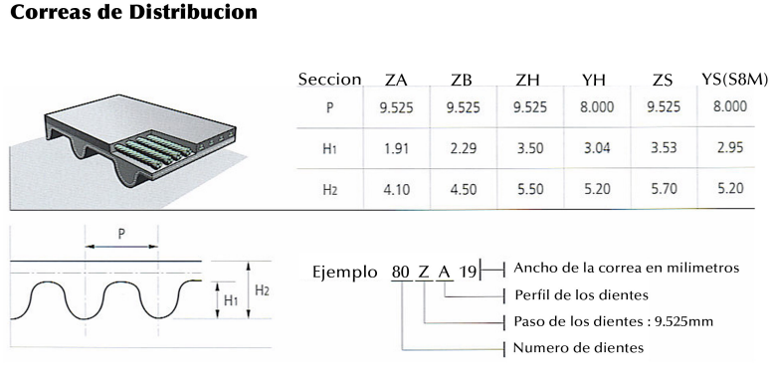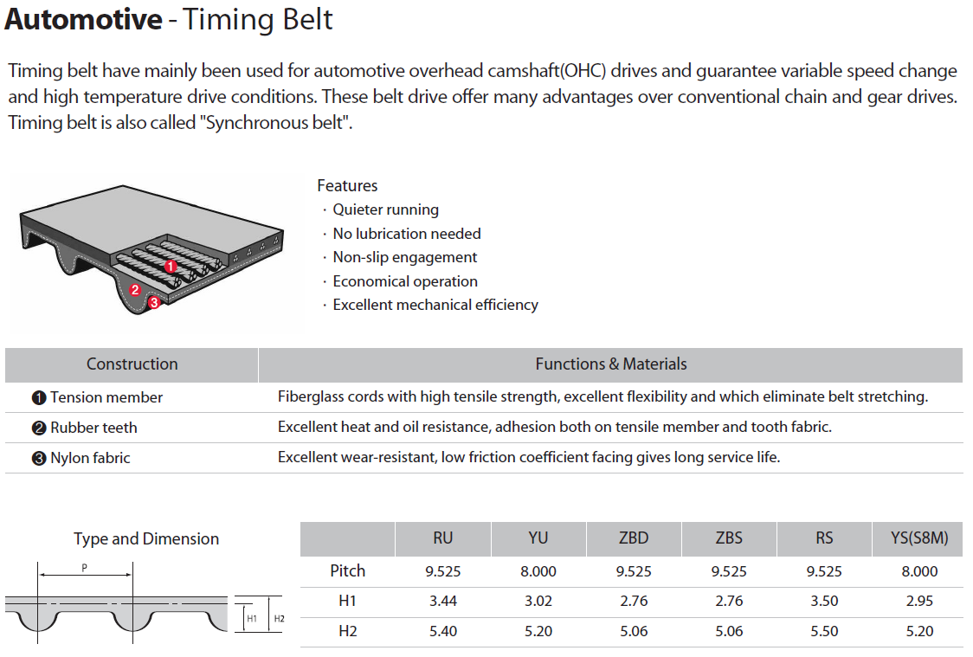****

|  |  |  |
| --- | --- | --- |
| * | **CR** | Caucho Cloropreno |
| ** | **HNBR** | Caucho Butadieno – Acrilonitrilo Hidrogenado |

**RU**

|  |  |  |  |  |
| --- | --- | --- | --- | --- |
|  |  | **CR\*** | **HNBR\*\*** | **HNBR\*\*** |
| **No. Correa** | **Ancho (in)** | **Peso Estimado (kg)** | **Peso Estimado (kg)** | **Peso estimado (lb)** |
| 91RU19.1 | 0.7520 | 0.1560 | 0.1320 | 0.0599 |
| 92RU22 | 0.8661 | 0.1800 | 0.1520 | 0.0689 |
| 105RU22 | 0.8860 | 0.2050 | 0.1740 | 0.0789 |
| 108RU25.4 | 1.0000 | 0.2470 | 0.2090 | 0.0948 |
| 111RU25.4 | 1.0000 | 0.2530 | 0.2150 | 0.0975 |
| 113RU24 | 0.9449 | 0.2450 | 0.2070 | 0.0939 |
| 113RU25.4 | 1.0000 | 0.2580 | 0.2180 | 0.0989 |
| 113RU25.8 | 1.0157 | 0.2580 | 0.2180 | 0.0989 |
| 122RU19 | 0.7480 | 0.2090 | 0.1770 | 0.0803 |
| 122RU19.1 | 0.7520 | 0.2090 | 0.1770 | 0.0803 |
| 122RU24 | 0.9449 | 0.2640 | 0.2240 | 0.1016 |
| 122RU29 | 1.1417 | 0.3140 | 0.2660 | 0.1207 |

|  |  |  |  |  |
| --- | --- | --- | --- | --- |
|  |  | **CR\*** | **HNBR\*\*** | **HNBR\*\*** |
| **No. Correa** | **Ancho (in)** | **Peso Estimado (kg)** | **Peso Estimado (kg)** | **Peso estimado (lb)** |
| 123RU24 | 0.9449 | 0.2660 | 0.2250 | 0.1021 |
| 123RU28 | 1.1024 | 0.3160 | 0.2680 | 0.1216 |
| 127RU25.4 | 1.0000 | 0.2910 | 0.2450 | 0.1111 |
| 149RU25 | 0.9843 | 0.3400 | 0.2880 | 0.1306 |
| 149RU25.4 | 1.0000 | 0.3400 | 0.2880 | 0.1306 |
| 151RU29 | 1.1417 | 0.3880 | 0.3280 | 0.1488 |
| 151RU30 | 1.1811 | 0.4140 | 0.3500 | 0.1588 |
| 153RU29 | 1.1417 | 0.3930 | 0.3330 | 0.1510 |
| 163RU25.4 | 1.0000 | 0.3720 | 0.3150 | 0.1429 |

**YU**

|  |  |  |  |  |
| --- | --- | --- | --- | --- |
|  |  | **CR\*** | **HNBR\*\*** | **HNBR\*\*** |
| **No. Correa** | **Ancho (in)** | **Peso Estimado (kg)** | **Peso Estimado (kg)** | **Peso estimado (lb)** |
| 65YU12.7 | 0.5000 | 0.0540 | 0.0460 | 0.0209 |
| 65YU13 | 0.5118 | 0.0560 | 0.0470 | 0.0213 |
| 99YU19.1 | 0.7520 | 0.1240 | 0.1050 | 0.0476 |
| 107YU22 | 0.8661 | 0.1530 | 0.1290 | 0.0585 |
| 107YU25 | 0.9843 | 0.1780 | 0.1510 | 0.0685 |
| 145YU22 | 0.8661 | 0.2070 | 0.1760 | 0.0798 |
| 154YU22 | 0.8661 | 0.2200 | 0.1870 | 0.0848 |
| 168YU22 | 0.8661 | 0.2400 | 0.2030 | 0.0921 |
| 168YU25.4 | 1.0000 | 0.2800 | 0.2370 | 0.1075 |
| 207YU32 | 1.2598 | 0.4440 | 0.3750 | 0.1701 |
| 259YU32 | 1.2598 | 0.5550 | 0.4710 | 0.2136 |

**ZBD/ZBS**

|  |  |  |  |  |
| --- | --- | --- | --- | --- |
|  |  | **CR\*** | **HNBR\*\*** | **HNBR\*\*** |
| **No. Correa** | **Ancho (in)** | **Peso Estimado (kg)** | **Peso Estimado (kg)** | **Peso estimado (lb)** |
| 55ZBD13 | 0.5118 | 0.0560 | 0.0480 | 0.0218 |
| 55ZBS12.7 | 0.5000 | 0.0540 | 0.0460 | 0.0209 |

**RS**

|  |  |  |  |  |
| --- | --- | --- | --- | --- |
|  |  | **CR\*** | **HNBR\*\*** | **HNBR\*\*** |
| **No. Correa** | **Ancho (in)** | **Peso Estimado (kg)** | **Peso Estimado (kg)** | **Peso estimado (lb)** |
| 111RS17 | 0.6693 | 0.1690 | 0.1440 | 0.0653 |
| 111RS20 | 0.7874 | 0.1980 | 0.1690 | 0.0767 |

**YS (S8M)**

|  |  |  |  |  |
| --- | --- | --- | --- | --- |
|  |  | **CR\*** | **HNBR\*\*** | **HNBR\*\*** |
| **No. Correa** | **Ancho (in)** | **Peso Estimado (kg)** | **Peso Estimado (kg)** | **Peso estimado (lb)** |
| 127S8M520 | 20.4725 | 0.0540 | 0.0530 | 0.0240 |
| 200S8M1168 | 45.9843 | 0.1910 | 0.1860 | 0.0844 |
| 240S8M1352 | 53.2284 | 0.2670 | 0.2600 | 0.1179 |
| 290S8M1352 | 53.2284 | 0.3170 | 0.3090 | 0.1402 |
| 290S8M1384 | 54.4882 | 0.3250 | 0.3160 | 0.1433 |